

BIT2002 – Biological Database

J-component Report Document

**Database on Plant Modification**

## By –

**YASH CHAWLA 19BCB0046**

## PRATEEK DHAWAN 19BCB0027

**CHEKURI KARTHIK 20BCB0043**

## *Under the guidance of –*

**Prof. Dr. Satarupa Banerjee**

## Introduction

Plant growth and development provides a precise coordination of the spatial and temporal organization of cell division, cell expansion and cell differentiation. Plant interactions with microorganisms have long been of interest as these interactions could lead to the development of novel agricultural uses.

Beyond nutrient cycling, microbes produce hormones and other chemicals to stimulate plant growth. Soil microbes can also prevent pathogen infection by inducing plant systemic disease resistance and by coating root surfaces to physically shield the plant from getting infected by pathogens.

The root system of the plant releases different compounds which create a different environment in the surrounding soil. These components generally lie in the 3 categories:

* Low molecular weight
* High molecular weight
* Volatile organic compounds

Low-molecular weight compounds represent the main portion of exudates and consist of sugars, amino acids, organic acids, phenolics, vitamins and various secondary metabolites.

High-molecular weight compounds consist of mucilage and proteins, while carbon dioxide, certain secondary metabolites, alcohols and aldehydes constitute volatiles.

Certain factors such as temperature, light, age and soil type can affect the nature and timing of exudation of these plants and certain compounds which release at exudation, act as signals for microbial attraction or to enhance microbial nutrition.

This project is concerned with the modification of plants. In this project, we will be discussing how microbes (both naturally occurring and artificially developed) can enhance the further development of plants.

This project will cover every aspect from growth to reproduction to fermentation to hormonal balance to plant disease resistance.

With the advent of new technologies such as biotechnology and nanotechnology, some microbes are developed in labs which further lead to the rapid growth of plants under different circumstances.

The detailed information will be covered in this project. A database will be maintained with CRUD operations storing all information and being responsive at times.

## Literature Survey

1. **Successful Plant Growth-Promoting Microbes: Inoculation Methods and Abiotic Factors** By – Monyck Jeane dos Santos Lopes, Moacyr Bernardino Dias-Filho, and Ely Simone Cajueiro Gurgel

Plant-microbe interactions have been the subject of several biotechnological studies, seeking sustainable development and environmental conservation. The inoculation of plant growth-promoting microbes (PGPM) in agricultural crops is considered an environmental- friendly alternative to chemical fertilization. Microbial inoculants are mainly inoculated onto seeds, roots and soil. PGPM improves plant growth by enhancing the availability of nutrients, the regulation of phytohormones, and by increasing plant tolerance against biotic and abiotic stresses.

### Plant growth-promoting bacteria as inoculants in agricultural soils

By – Rocheli de Souza, Adriana Ambrosini, and Luciane M.P. Passaglia

Plant-microbe interactions in the rhizosphere are the determinants of plant health, productivity and soil fertility. Plant growth-promoting bacteria (PGPB) are bacteria that can enhance plant growth and protect plants from disease and abiotic stresses through a wide variety of mechanisms; those that establish close associations with plants, such as the endophytes, could be more successful in plant growth promotion. Several important bacterial characteristics, such as biological nitrogen fixation, phosphate solubilization, ACC deaminase activity, and production of siderophores and phytohormones, can be assessed as plant growth promotion (PGP) traits.

### Genetically modified seeds and plant propagating material in Europe: potential routes of entrance and current status

By – Nils Rostoks, Lelde Grantiņa-Ieviņa, Baiba Ieviņa, Velta Evelone, Olga Valciņa, Inese Aleksejeva

Genetically modified organisms (GMO), mainly crop plants, are increasingly grown worldwide leading to large trade volumes of living seeds and other plant material both for cultivation and for food and animal feed. In this review, we identify the possible entrance routes of GM seeds and other propagating plant material in the EU which could be linked to unauthorized release of GMOs in the environment. In addition, we discuss the situation with GM plant cultivation in some non-EU countries in terms of potential risks for GM seed imports.

### MIPSPlantsDB—plant database resource for integrative and comparative plant genome research

By – Manuel Spannagl, Octave Noubibou, Dirk Haase, Li Yang, Heidrun Gundlach, Tobias Hindemitt, Kathrin Klee, Georg Haberer, Heiko Schoof, Klaus F. X. Mayer

Genome-oriented plant research delivers a rapidly increasing amount of plant genome data. Comprehensive and structured information resources are required to structure and communicate genome and associated analytical data for model organisms as well as for crops. The increase in available plant genomic data enables powerful comparative analysis and integrative approaches. PlantsDB aims to provide data and information resources for individual plant species and in addition to build a platform for integrative and comparative plant genome research.

### P3DB: an integrated database for plant protein phosphorylation

By – Qiuming Yao, Curtis Bollinger, Jianjiong Gao, Dong Xu and Jay J. Thelen

Protein phosphorylation is widely recognized as the most widespread, enzyme-catalyzed post-translational modification in eukaryotes. To archive these events in a user-intuitive format we have developed P3DB, the Plant Protein Phosphorylation Database (p3db.org). This database is a repository for plant protein phosphorylation site data, currently hosting information on 32,963 non-redundant sites collated from 23 experimental studies from six plant species. The paper demonstrates how this resource can help identify functionally conserved phosphorylation sites in plants using a multi-system approach.

## Methodology Used

* We collected sample data entries of certain crops/plants grown in the soil, and fed them to the database created.
* Different microbes were identified with details, origin and functions from all the research papers collected.
* We tend to create an application to provide a prototype to create a real-world data implementation.
* The models presented have been implemented in java by creating databases and connecting them with SQL.

**COLLECTION OF DATA:**

1.After studying different research papers, review papers, browsing over the internet data is collected.

2.The main criteria for collection of data is their function which helps the different regions of the plant to grow well.

3.The data includes the microbes which are developed both naturally and manually.

**METADATA OF DATA:**

1.The major information about the microbes such as their origin, their functions and their real life applications is collected.

2.Nature of microbes is also kept in mind while studying. If they are naturally occurring then where they are found, what are suitable and required conditions for their growth and if they are artificially developed then what are their origin.

**IMPLEMENTATION OF MODEL**:

1.We worked on the approach of creating GUI’S in front and storing data in backend.

2.For frontend part we implemented JAVA, while for backend part we used JDBC connected with MySql server.

3.The reason for using java is its inbuilt salient features of javax.swing libraries and great functionalities provided by jdbc which provide a real time environment of user friendly interfaces and secure data storage.

**STORING OF DATA:**

1.We created a MySQL database connected by JDBC(Java Database Connectivity) through GUI’s at front.

2.The data coming from it directly got stored into the tables created at the backend(Relational database schema).

3.We applied a security key due to which the security of the database was enhanced.

**Things kept in mind while implementing model:**

1.Role based security is provided for different users.For example the founder cannot access the functionalities of the middleman and vice versa.

2.Admin is given high priority with proveliage of modifying, deleting, inserting,searching and reading any record.

3.Proper check is maintained at the time of login to the database even for admin too.Thus ensuring validation and verification.

4.The data collected is collected from the verified sites and is fully correct authorized by ncbi.With every entry a link is provided directing to a webpage providing in depth information about that microbe.

5.Data flow is checked and tested.

**ARCHITECTURE DIAGRAM**

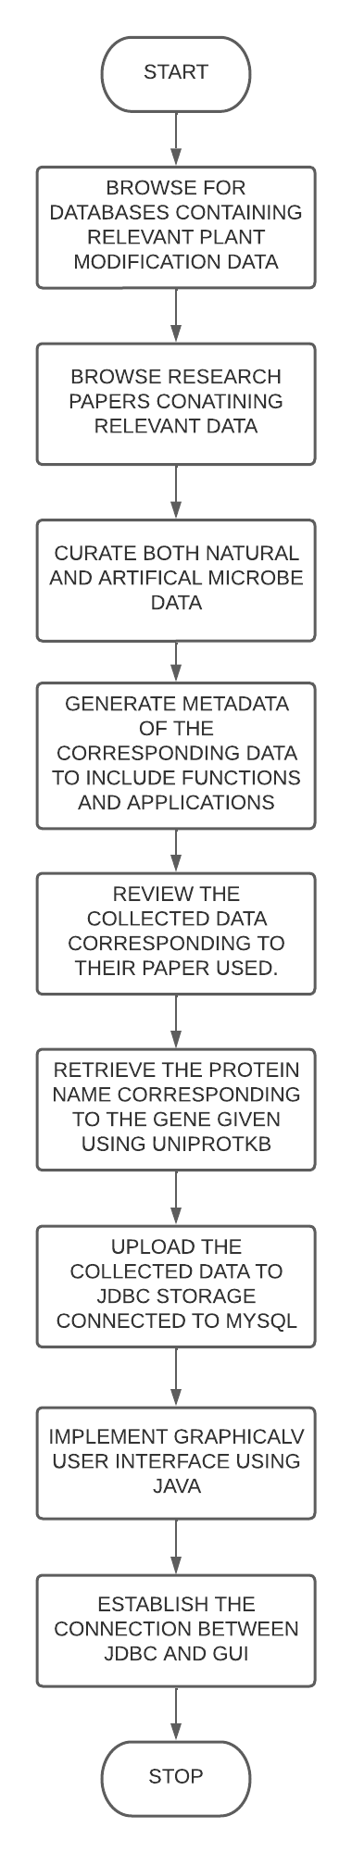

# Implementation

**Initiation the Java code**

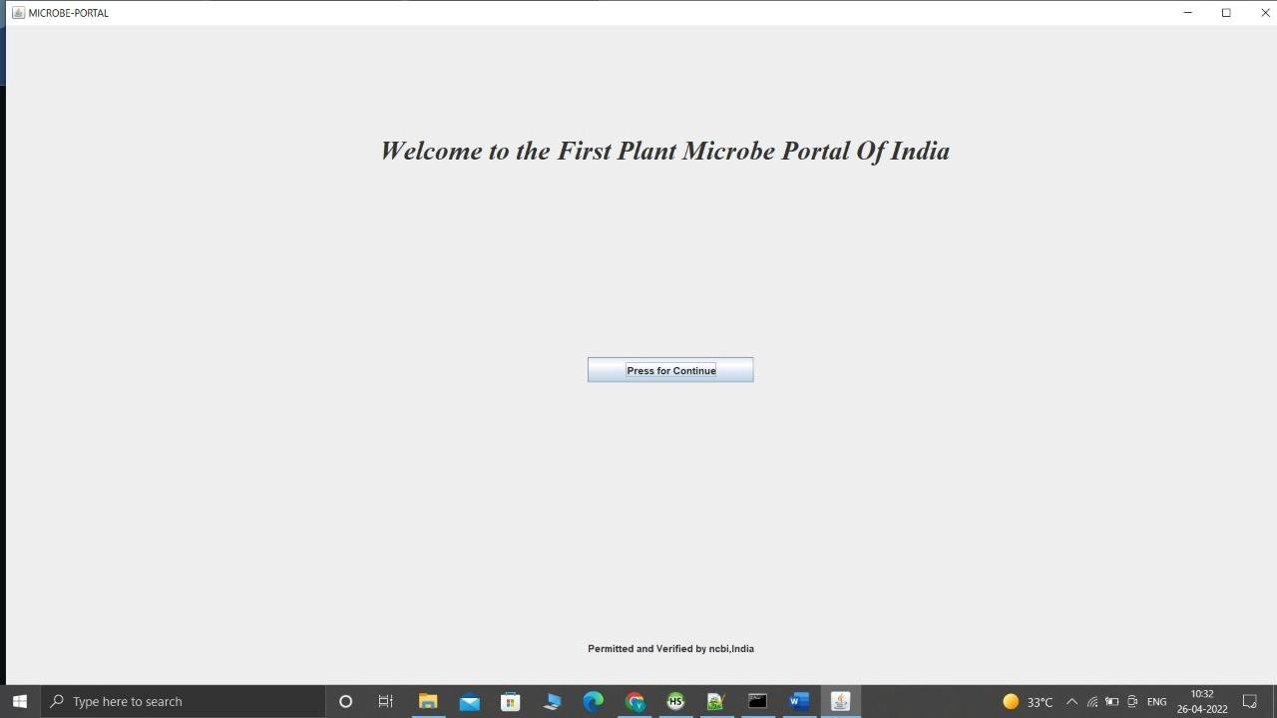

**Welcome page for the Website**





**Fig: Main Menu for the Website**



**Fig : Enter a new record** 

**Fig : Admin Panel**

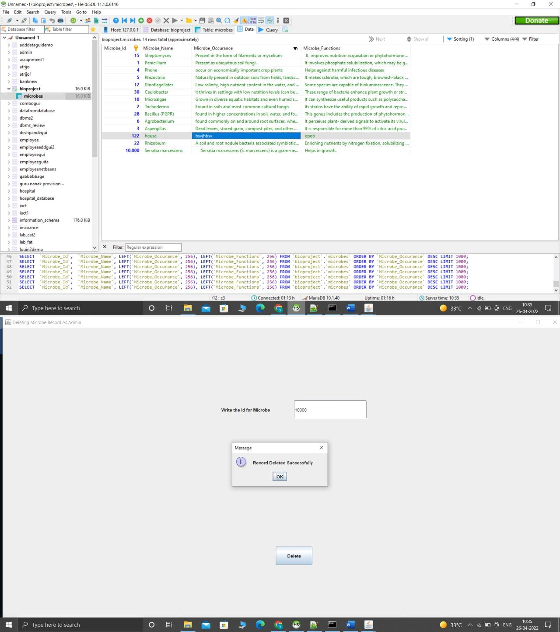

**Fig : Display and Delete page**

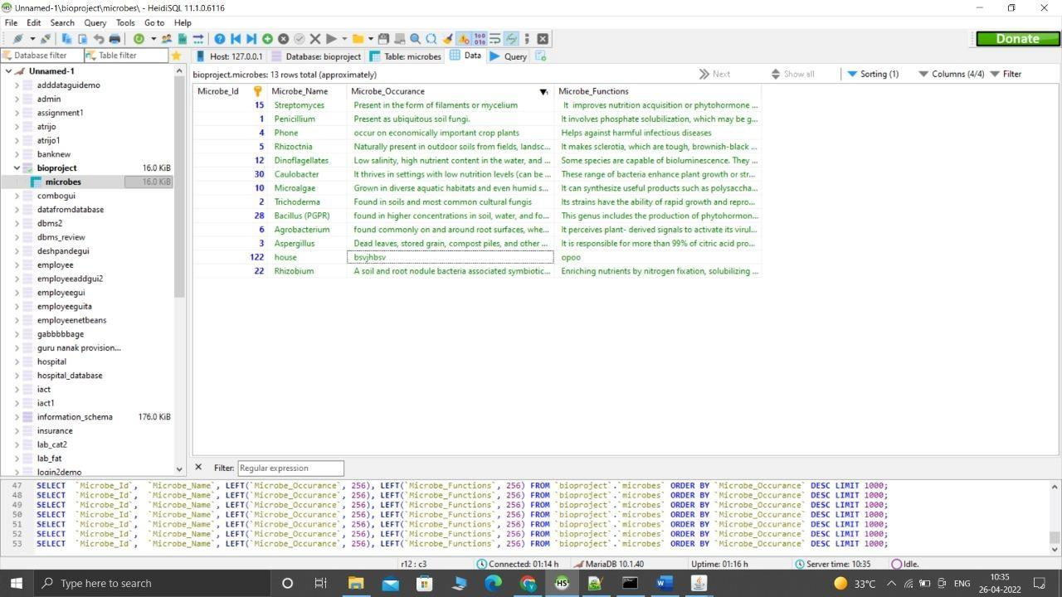

For verifying the data record of the microbe and its necessary data entries from the database –



**Fig : Searching the Records**

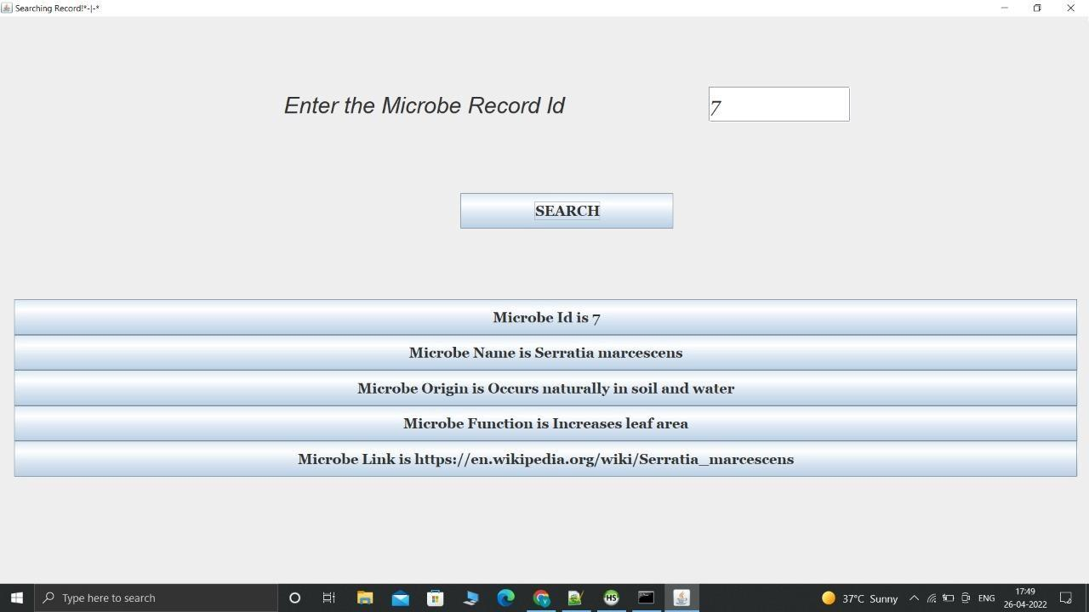

# Tech Stack Used

* We have used **JDBC** in backend.
* We have used a **MySQL** database on the **XAMPP** server.
* For the frontend web interface framework, we used GUI for providing a graphical view of the data.

## Work Done

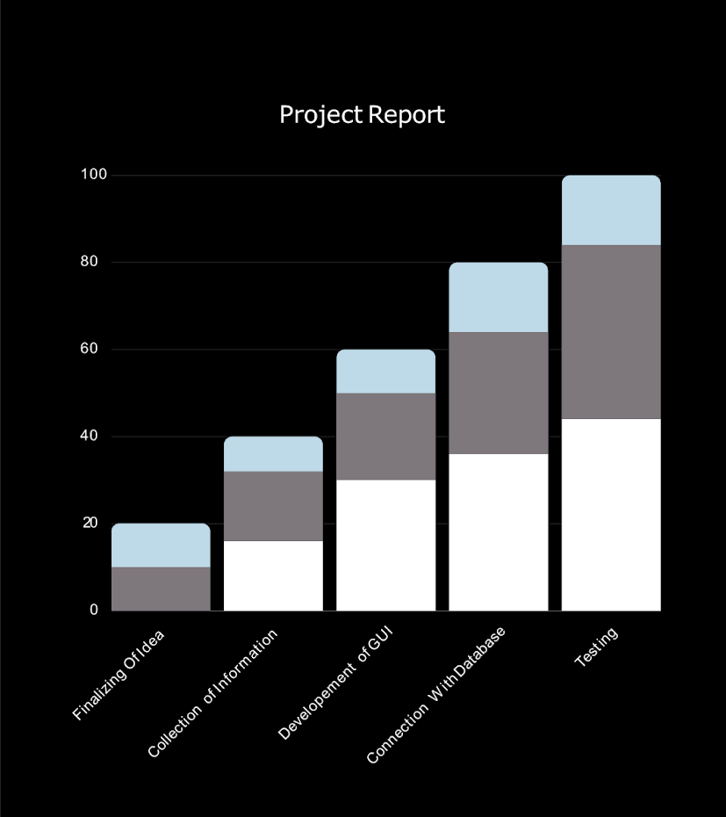

**Fig : Project WorkFlow**

**( Number of days vs Work done )**

**References**

1.Töpfer, R., Martini, N., & Schell, J. (1995). Modification of plant lipid synthesis. Science, 268(5211), 681-686.

2.Akharume, F. U., Aluko, R. E., & Adedeji, A. A. (2021). Modification of plant proteins for improved functionality: A review. *Comprehensive Reviews in Food Science and Food Safety*, *20*(1), 198-224.

3.Yuan, L., & Knauf, V. C. (1997). Modification of plant components. *Current opinion in biotechnology*, *8*(2), 227-233.

| 4.Moss, D. N., Woolley, J. T., & Stone, J. F. (1975). Plant modification for more efficient water use: the challenge. In *Developments in Agricultural and Managed Forest Ecology* (Vol. 1, pp. 311-320). Elsevier.  5. Bottrell, D. G., Barbosa, P., & Gould, F. (1998). Manipulating natural enemies by plant variety selection and modification: a realistic strategy?. Annual review of entomology, 43(1), 347-367.  6. Tian, B., & Liu, J. (2020). Resveratrol: A review of plant sources, synthesis, stability, modification and food application. Journal of the Science of Food and Agriculture, 100(4), 1392-1404.  7. Chandler, S. F., & Sanchez, C. (2012). Genetic modification; the development of transgenic ornamental plant varieties. Plant biotechnology journal, 10(8), 891-903.  8. McCleary, B. V. (1986). Enzymatic modification of plant polysaccharides. International Journal of Biological Macromolecules, 8(6), 349-354.  9. Shen, Q., Lin, Y., Li, Y., & Wang, G. (2021). Dynamics of H3K27me3 modification on plant adaptation to environmental cues. Plants, 10(6), 1165.  10.Hartmann, A., Schmid, M., Tuinen, D. V., & Berg, G. (2009). Plant-driven selection of microbes. Plant and Soil, 321(1), 235-257.  11.Montesinos, E. (2003). Plant-associated microorganisms: a view from the scope of microbiology. International Microbiology, 6(4), 221-223.  12.Fitzpatrick, C. R., Mustafa, Z., & Viliunas, J. (2019). Soil microbes alter plant fitness under competition and drought. Journal of Evolutionary Biology, 32(5), 438-450.  13.Selosse, M. A., Bessis, A., & Pozo, M. J. (2014). Microbial priming of plant and animal immunity: symbionts as developmental signals. Trends in microbiology, 22(11), 607-613.  14.Spaepen, S., & Vanderleyden, J. (2011). Auxin and plant-microbe interactions. Cold Spring Harbor perspectives in biology, 3(4), a001438.  15.Raaijmakers, J. M., Vlami, M., & De Souza, J. T. (2002). Antibiotic production by bacterial biocontrol agents. Antonie van leeuwenhoek, 81(1), 537-547.  16.Arif, I., Batool, M., & Schenk, P. M. (2020). Plant microbiome engineering: expected benefits for improved crop growth and resilience. Trends in Biotechnology, 38(12), 1385-1396.  17.Mueller, U. G., & Sachs, J. L. (2015). Engineering microbiomes to improve plant and animal health. Trends in microbiology, 23(10), 606-617.  18.Richardson, A. E., Lynch, J. P., Ryan, P. R., Delhaize, E., Smith, F. A., Smith, S. E., ... & Simpson, R. J. (2011). Plant and microbial strategies to improve the phosphorus efficiency of agriculture. Plant and soil, 349(1), 121-156.  19.Mei, C., & Flinn, B. S. (2010). The use of beneficial microbial endophytes for plant biomass and stress tolerance improvement. Recent patents on biotechnology, 4(1), 81-95.  20.Lamb, E. G., Kennedy, N., & Siciliano, S. D. (2011). Effects of plant species richness and evenness on soil microbial community diversity and function. Plant and Soil, 338(1), 483-495. |
| --- |